Experiment-2

Aim:
Illustrate and implement the state space representation of Water Jug using Prolog.

Theory:-
Prolog or PROgramming in LOGics is a logical and declarative programming language. It is one major example of the fourth generation language that supports the declarative programming paradigm. This is particularly suitable for programs that involve symbolic or non-numeric computation.
Prolog is a declarative language that means we can specify what problem we want to solve rather than how to solve it.
Prolog is used in some areas like databases, natural language processing, artificial intelligence, but it is pretty useless in some areas like a numerical algorithm or instance graphics. In artificial intelligence applications, prolog is used. The artificial intelligence applications can be automated reasoning systems, natural language interfaces, and expert systems. The expert system consists of an interface engine and a database of facts. The prolog's run time system provides the service of an interface engine.
A basic logic programming environment has no literal values. An identifier with upper case letters and other identifiers denote variables. Identifiers that start with lower-case letters denote data values. The basic Prolog elements are typeless. The most implementations of prolog have been enhanced to include integer value, characters, and operations. The Mechanism of prolog describes the tuples and lists.
Functional programming language and prolog have some similarities like Hugs. A logic program is used to consist of relation definition. A functional programming language is used to consist of a sequence of function definitions. Both the logical programming and functional programming rely heavily on recursive definitions.
Applications of Prolog-
The applications of prolog are as follows:
- Specification Language
- Robot Planning
- Natural language understanding
- Machine Learning
- Problem Solving
- Intelligent Database retrieval
- Expert System
- Automated Reasoning
The Water Jug Problem in Artificial Intelligence is a classic puzzle in AI and mathematics that focuses on optimizing the use of two or more water jugs to measure a specific quantity of water. It is a fundamental problem in the domain of optimization and decision-making. This problem comes in various forms with different jug capacities and target measurements, making it a versatile tool for learning AI problem-solving techniques.

Here two jugs of water are given, say one is a 4-litre one, and the other one is a 3-litre one, but none of the measuring markers is mentioned on any of it. There is a pump available to fill the jugs with water. How can you exactly pour 2 litres of water into a 4-litre jug? Assuming that both the jugs are empty, the task is to find a solution to pour 2-litre water into a 4-litre jug.

To solve the water jug problem, many algorithms can be used. These include:
- Breadth-First Search: BFS or Breadth First Search visits the nodes in order of their distance from the starting node. This implies that it will visit the nearest node first.
- Depth First Search: DFS or Depth First Search visits the nodes in order of their depth.
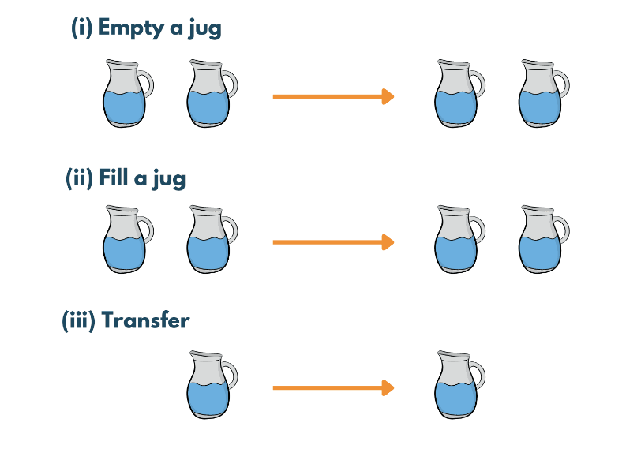

In production rules for the water jug problem, let x denote a 4-litre jug, and y denote a 3-litre jug, i.e. x=0,1,2,3,4 or y=0,1,2,3

Start state (0,0)
Goal state (2,n) from any n

Start from the start state and end up at the goal state. Production rules for the water jug problem in AI are as follows:
1. | (x,y) is X<4 -> (4, Y) | Fill the 4-litre jug
2. | (x, y) if Y<3 -> (x, 3) | Fill the 3-litre jug
3. | (x, y) if x>0 -> (x-d, d) | Pour some water from a 4-litre jug
4. | (x, y) if Y>0 -> (d, y-d) | Pour some water from a 3-litre jug
5. | (x, y) if x>0 -> (0, y) | Empty 4-litre jug on the ground
6. | (x, y) if y>0 -> (x,0) | Empty 3-litre jug on the ground
7. | (x, y) if X+Y >= 4 and y>0 -> (4, y-(4-x | Pour water from a 3-litre jug into a 4-litre jug until it is full
8. | (x, y) if X+Y>=3 and x>0 -> (x-(3-y), 3) | Pour water from a 3-litre jug into a 4-litre jug until it is full
9. | (x, y) if X+Y <=4 and y>0 -> (x+y, 0 | Pour all the water from a 3-litre jug into a 4-litre jug
10. | (x, y) if X+Y<=3 and x>0 -> (0, x+ | Pour all the water from a 4-litre jug into a 3-litre jug
11. | (0, 2) -> (2, 0) | Pour 2-litre water from 3-litre jug into 4-litre jug
12. | (2, Y) -> (0, y) | Empty 2-litre in the 4-litre jug on the ground.

Code:-
fill(x,y).
fill(2,0):-nl,
write('Goal State Attained:').
fill(X,Y):-X=0,Y=<1,
nl,
write('Filling the 4-Gallon jug:(4,'),
write(Y),
write(')'),
fill(4,Y).
fill(X,Y):- Y=0,X=3,
nl,
write('Filling the 3-Gallon jug:('),
write(X),
write(',3)'),
fill(X,3).
fill(X,Y):- X+Y>=4,Y=3,X=3,
Y1 is Y-(4-X),
nl,
write('Pouring Water from 3-gallon jug to 4-gallon jug until full:(4,'),
write(Y1),
write(')'),
fill(4,Y1).
fill(X,Y):- X+Y>=3,Y=<1,X=4,
X1 is X-(3-Y),
nl,
write('Pouring Water from 4-gallon jug to 3-gallon jug until full:('),
write(X1),
write(',3)'),
fill(X1,3).
fill(X,Y):- X+Y=<4,X=0,Y>1,
X1 is X+Y,
nl,
write('Pouring all the Water from 3-gallon jug to 4-gallon jug:('),
write(X1),
write(',0)'),
fill(X1,0).
fill(X,Y):- X+Y<3,Y=0,
Y1 is X+Y,
nl,
write('Pouring all the Water from 4-gallon jug to 3-gallon jug:(0,'),
write(Y1),
write(')'),
fill(0,Y1).
fill(X,Y):- Y=2,X=4,
nl,
write('Empty 4-gallon jug on ground:(0,'),
write(Y),
write(')'),
fill(0,Y).
fill(X,Y):- Y=3,X>=1,
nl,
write('Empty 3-gallon jug on ground:('),
write(X),
write(',0)'),
fill(X,0).
fill(X,Y):- X>4,Y<3,

write('4-gallon jug overflow:'),
nl.
fill(X,Y):- X<4,Y>3,

write('3-gallon jug overflow:'),
nl.
fill(X,Y):- X>4,Y>3,

write('4-gallon jug and 3-gallon jug overflow:'),
nl.

Output:-

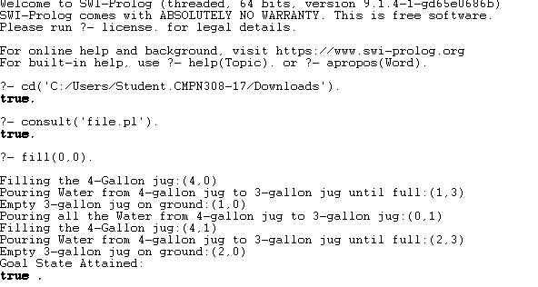

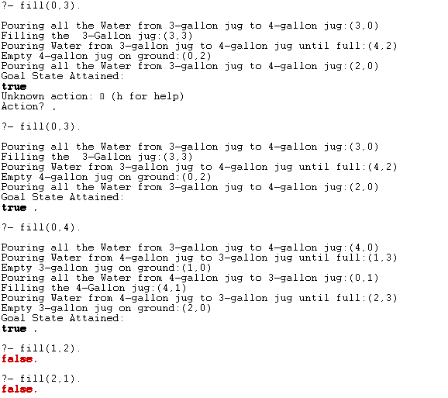

Conclusion:-
Hence, the state space representation of the Water Jug problem involves defining states as combinations of water levels in the jugs and actions as operations such as filling, emptying, or transferring water between jugs. Each state transition represents a move in the problem-solving process, aiming to reach the desired state where one jug contains a specified volume of water. Through techniques like depth-first search or breadth-first search, the optimal sequence of actions can be determined to achieve the goal state efficiently. This representation facilitates algorithmic approaches to solving the Water Jug problem and illustrates fundamental concepts in problem-solving, such as state space exploration and search strategies.

